**AMA COMPUTER COLLEGE MAKATI**

AMA One Bldg/RVG Bldg.,5486 South Superhighway Bangkal, Makati City

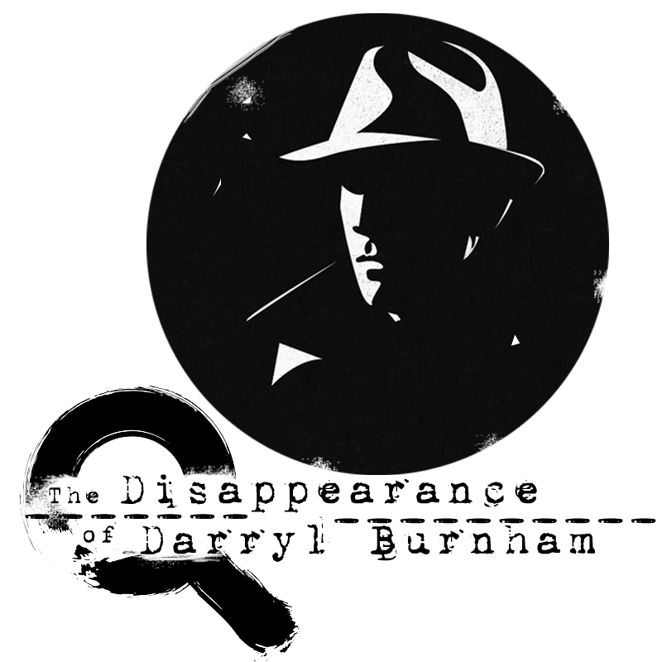

**The Disappearance of Darryl Burnham**

In partial fulfillment of the requirements in Java Programming Part I

Members:

Hassan, Adnan T.

Fernandez, Macaela

<March, 2020>

**Revision Table**

| Revision No. | Date | Description |
| --- | --- | --- |
| 1 | 3/3/2020 11:30am-6:00pm | The Creation of Project Documentation. |
| 2 | 3/6/2020 2:00am-2:30am | Created the logo and document it in pegs and bibliography section. |
| 3 | 3/13/2020 7:30am-8:00am | Finished the data flowchart. |
| 4 | 3/16/2020 9:30pm-10:50pm | Started the second room then documented it in pegs and bibliography section. Added the user interface. |
| 5 | 3/17/2020 3:45pm-3:55pm | Added context in user manual section. |
|  |  |  |
|  |  |  |
|  |  |  |
|  |  |  |

1. **Introduction**
2. Project Overview

The Disappearance of Darryl Burnham is a Point and Click Mystery Escape room puzzle game that focuses on the discovery and exploration of the story. It does not contain combat.

1. Project Description

* Find your way out
* Find the clues
* Use the clues to open/solve something

1. Project Pegs

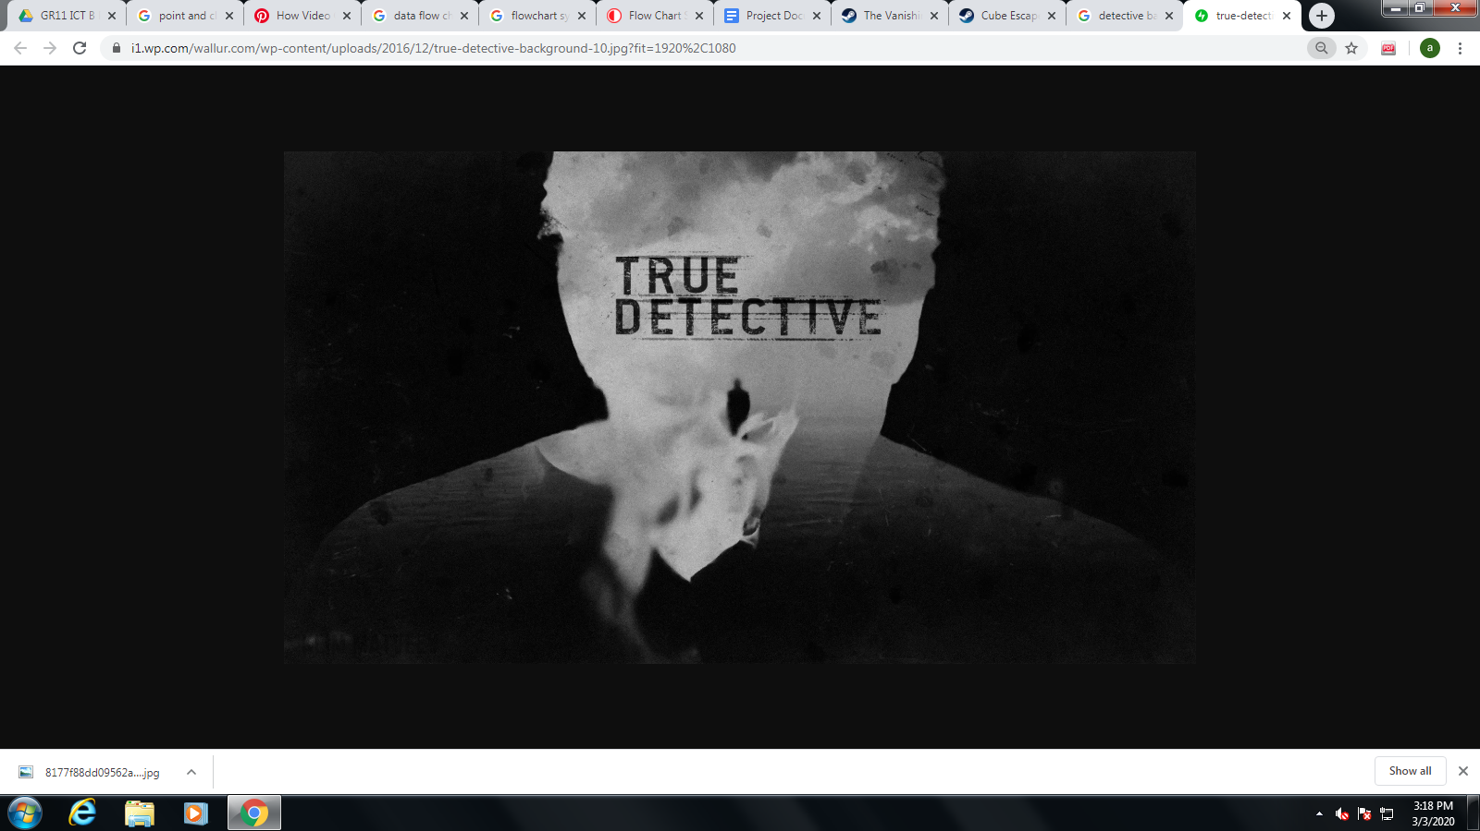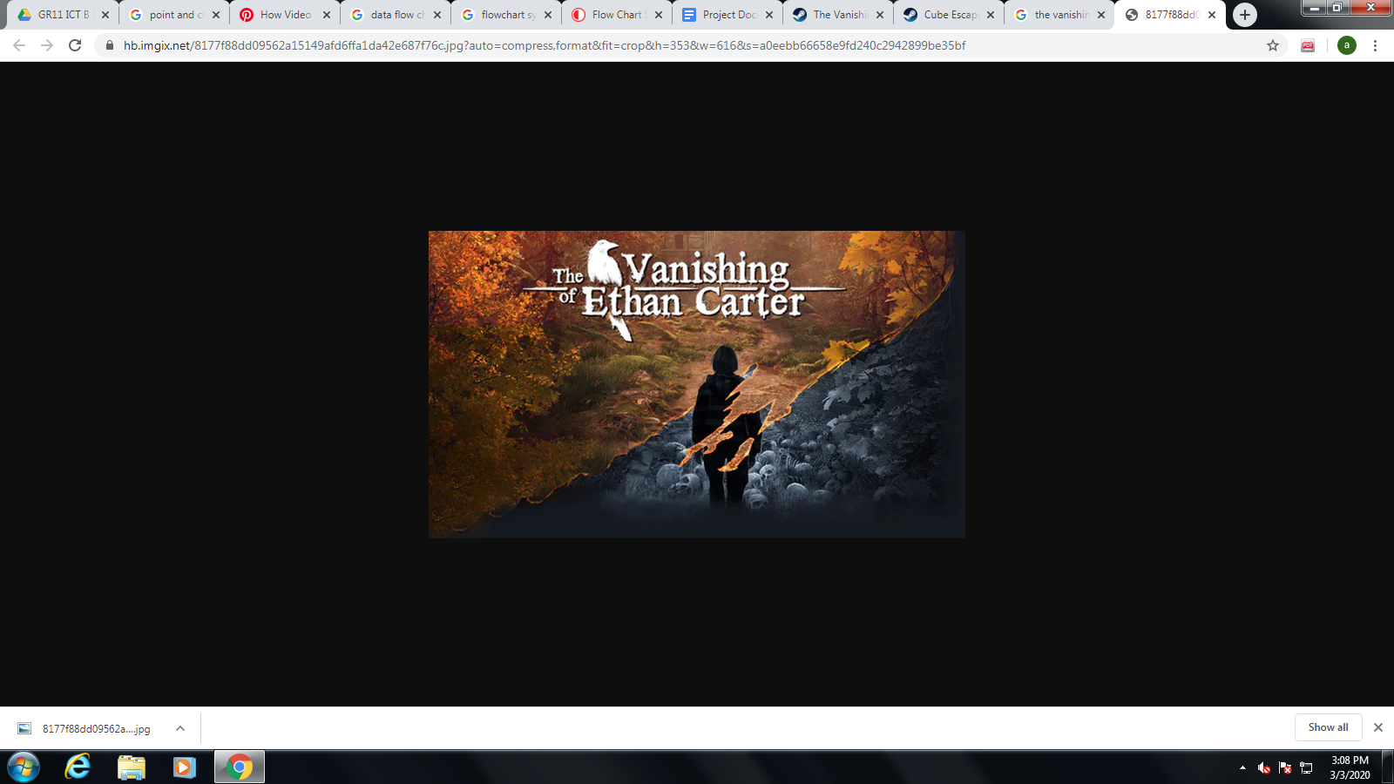

*Picture 01. Title screen of the game called the Vanishing of Ethan Carter.*

*Picture 02. Black and White Background that I found online.*

I combined this two pictures to create our title screen in picture 1 We mimic their

title for future concept. In picture 2 we used the Black and White concept.

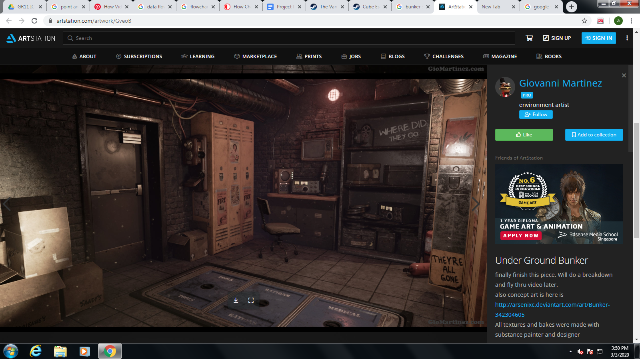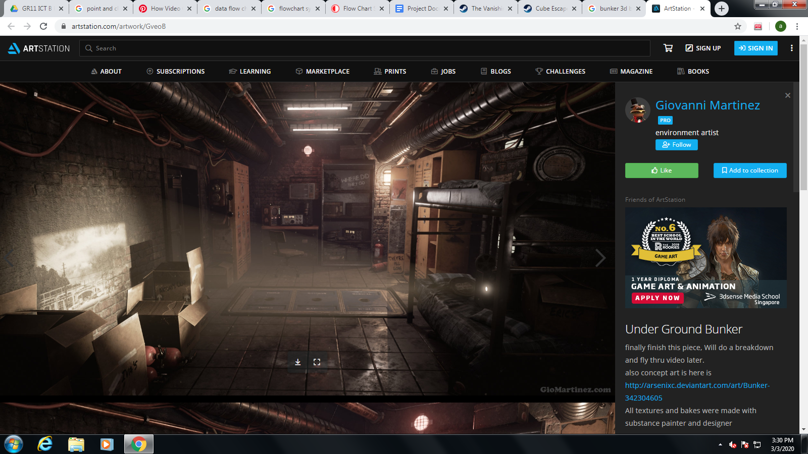

*Picture 03 & 04. 3D art of Giovanni Martines posted in ArtStation*

We used his arts to let the player feel the thrill and chill atmosphere of the game.

But we photoshop the picture and change its color to Monochrome to match with our title screen.

*Picture 05. A point and click game called Cube Escape: Paradox*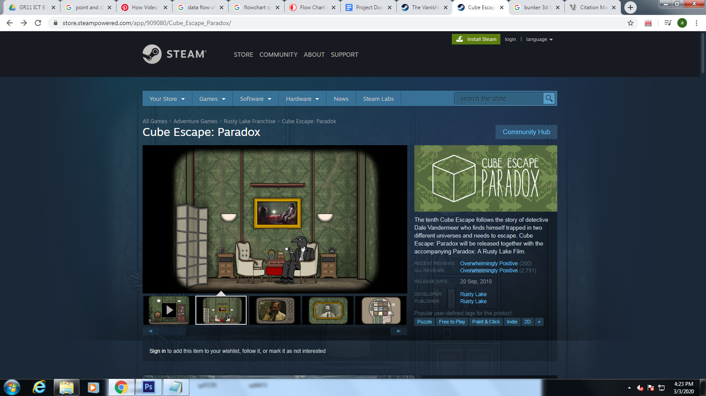

I copied their concept of an escape room game.



*Picture 06 & 07 Detective Style picture that we found online*

We combined these two to create our logo.

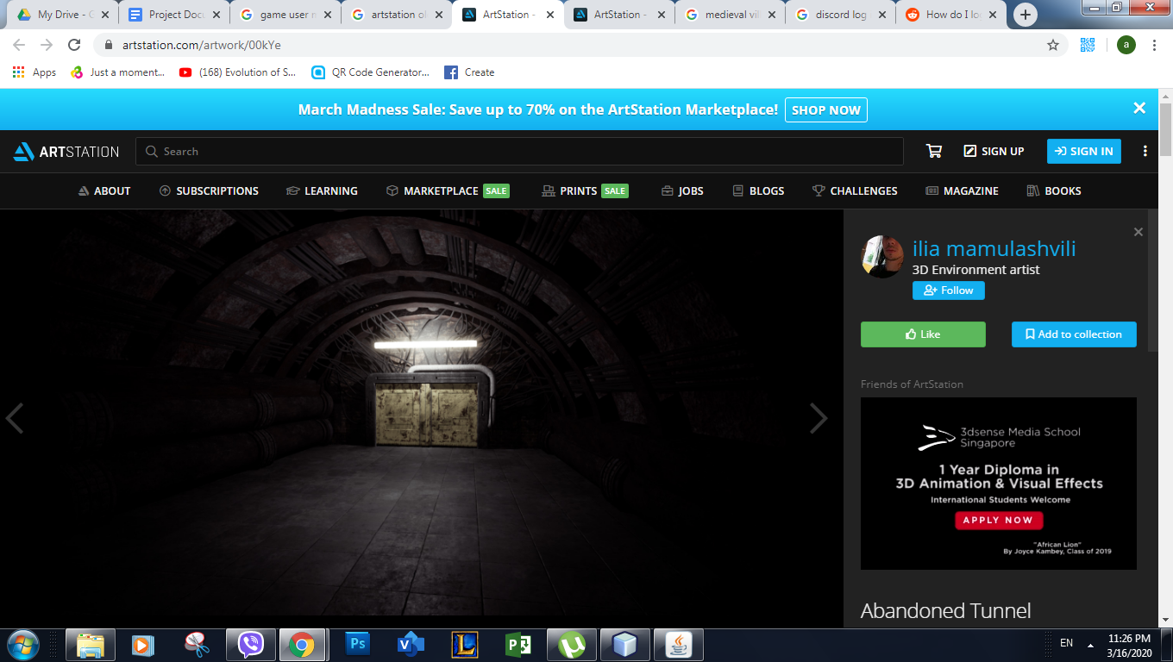

*Picture 08 art of Evgeny Borzaev*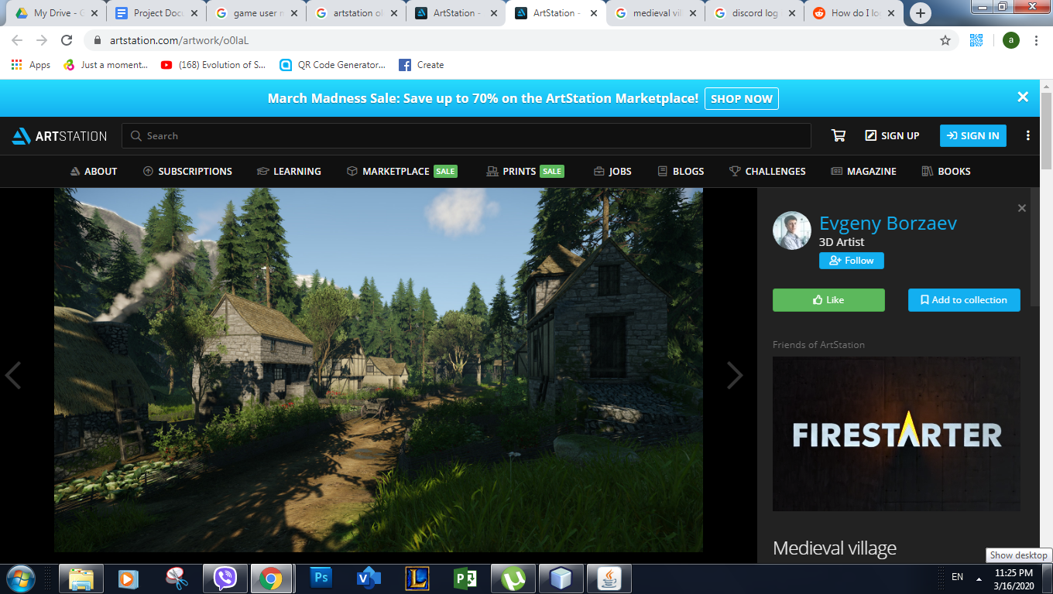

We used his art give the game an old vibe feeling but we photoshop it a change the color to match with other background.

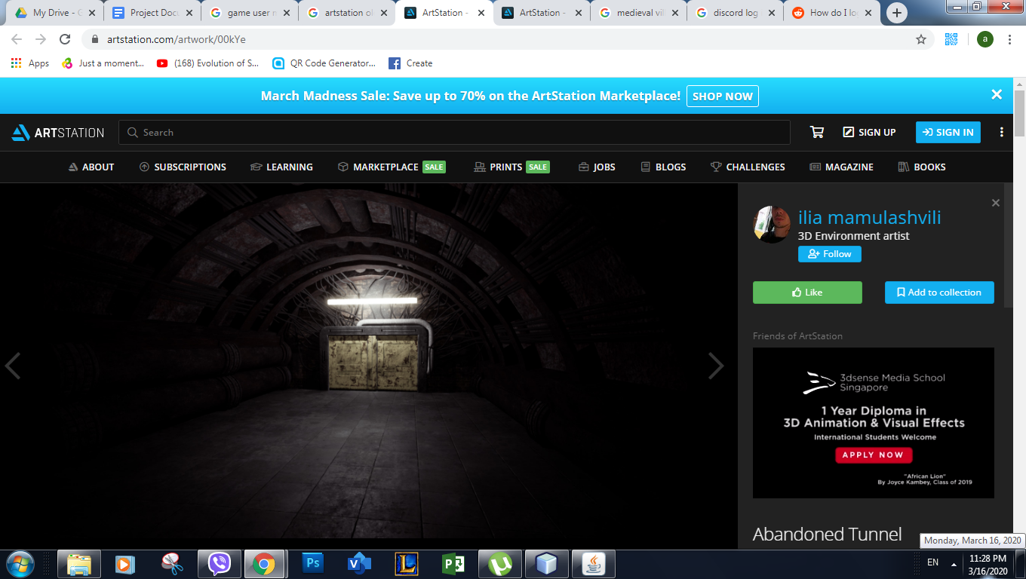

*Picture 09 art of ilia mamulashvili*

We also use this art and photoshop it to match with other background.

**II. Specific Description**

a. User Interface

*Title Screen*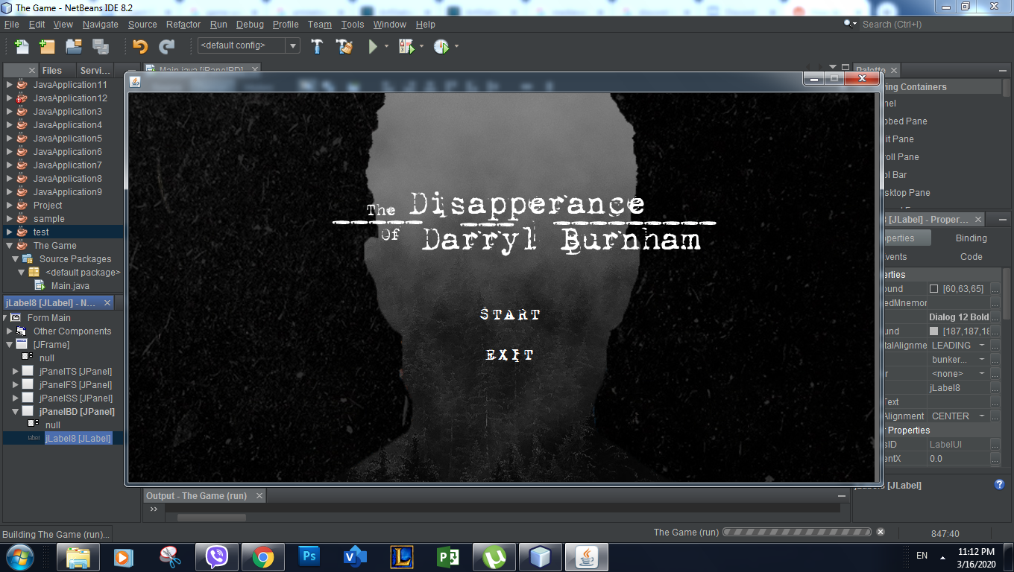

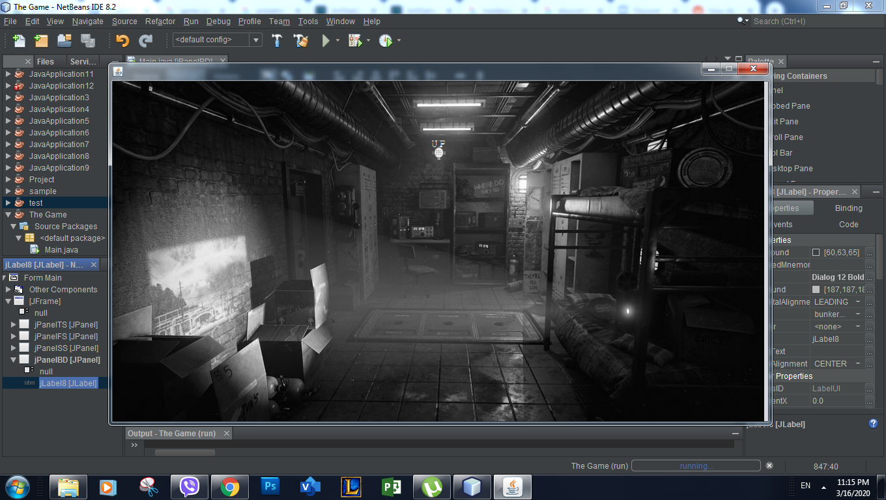

*First Room*

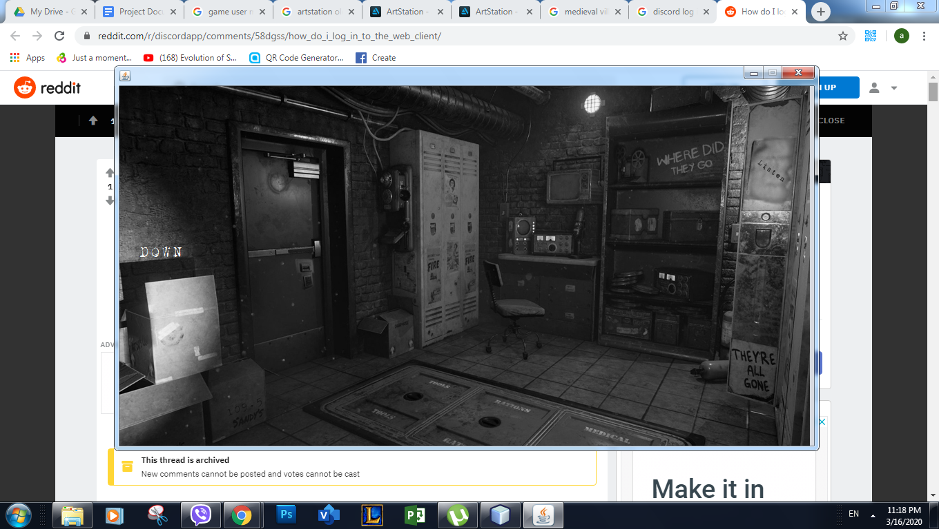

*First Room*

*Second room*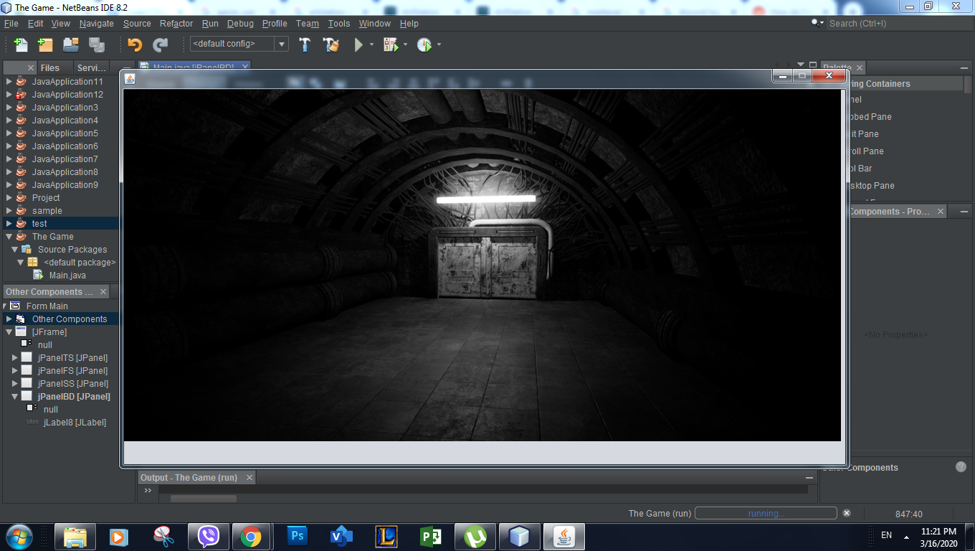

b. Data Flowchart

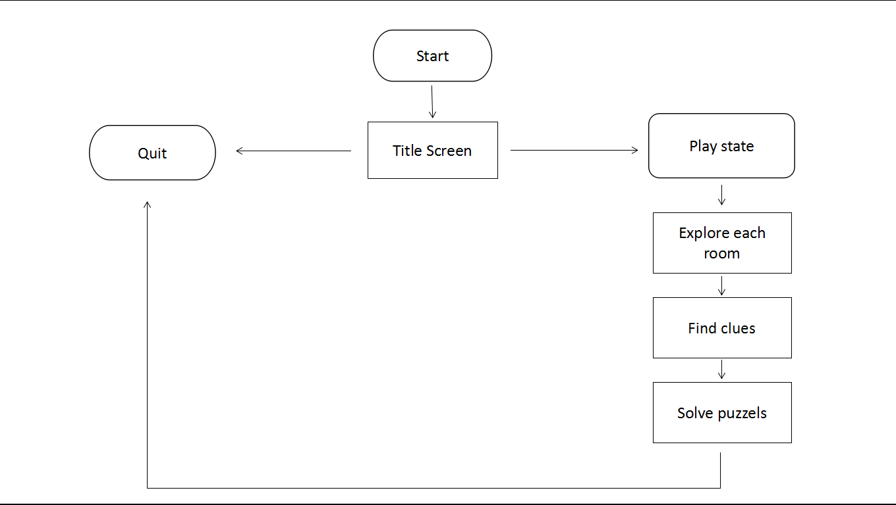

**III. User Manual**

1. Opening the game

Open the folder called "Puzzle game"

Right click the EXE/executable jar file then click open

B. Playing the game

Simply click the start button

Find the clues, solve things, and escape

C. Complications

There might be some complications when you run the game. Like in the title screen if you move around your cursor the invisible button may appear. To solve this move around the your cursor until you found a button called "DOWN". Or exit the game and reopen it.

**IV. Bibliography (APA Format)**

Picture 01. The Vanishing of Ethan Carter on Steam. (n.d.). Retrieved from https://store.steampowered.com/app/258520/The_Vanishing_of_Ethan_Carter/

Picture 02. True Detective HD Wallpaper & Background • 36683 • Wallur. (2016, December 30). Retrieved from <http://wallur.com/wallpaper/36683>

Picture 03 & 04. <https://www.artstation.com/artwork/GveoB>

Picture 05. Cube Escape: Paradox on Steam. (n.d.). Retrieved from <https://store.steampowered.com/app/909080/Cube_Escape_Paradox/>

Picture 08. <https://www.artstation.com/artwork/o0laL>

Picture 09. <https://www.artstation.com/artwork/00kYe>

**V. Documentation**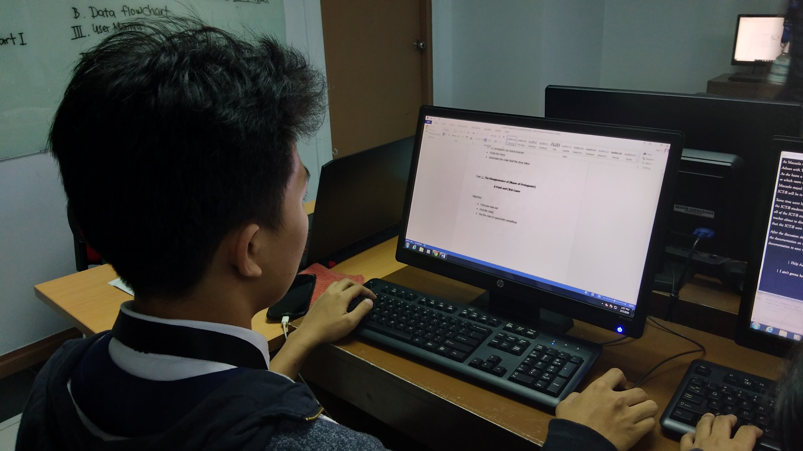

*Picture of Adnan doing our Project Documentation. (3/3/2020)*